

Figma Design

Login & Registration Page



Jacob Kurien

Roll No:19

S9 int mca

**Login and Registration Page FIGMA Design**

**Login**

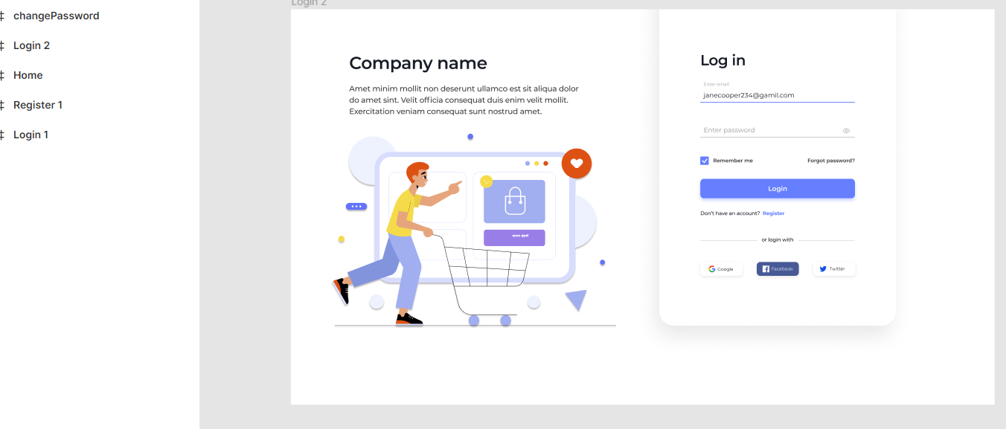

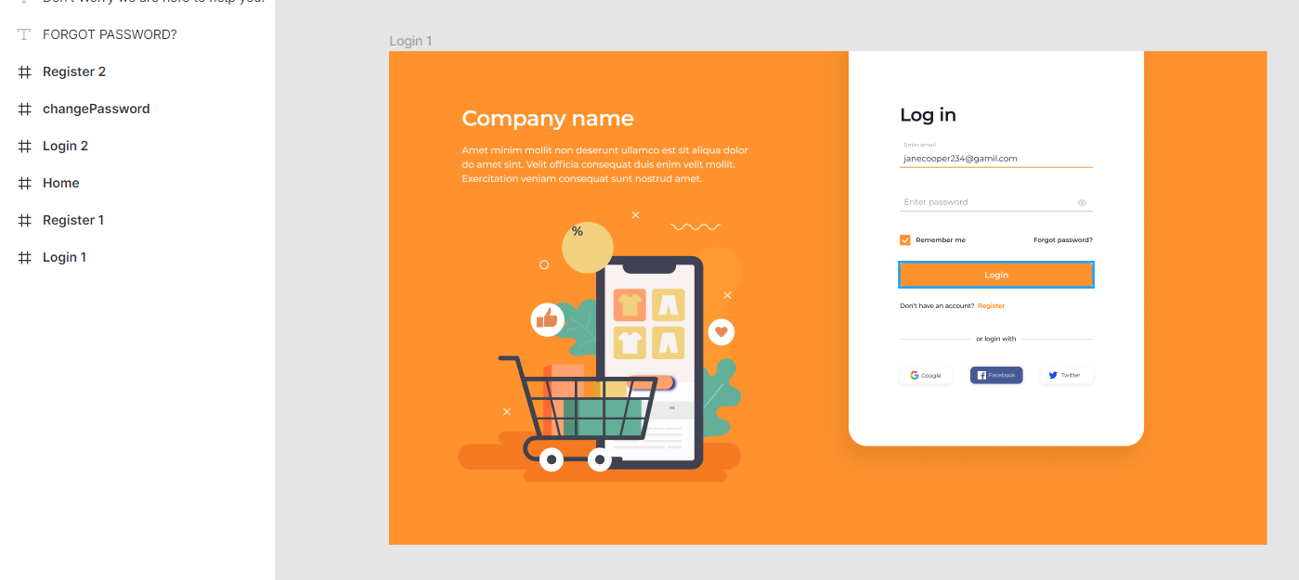

**Register**



